Inter-sector Study on
Web Accessibility
Summary

December 2007

Cross-Sector Study on Website Accessibility

The Discapnet Information Accessibility Monitor is an initiative from the Operative Program to Fight Discrimination, co-financed by the ONCE Foundation of Spain and the European Social Fund to improve digital literacy and access to the Information Society for the disabled.

After 3 years’ work and the publication of 8 reports, the Discapnet Information Accessibility Monitor has undertaken the present study to offer a cross-sector view of its evolution over time and the current state of web accessibility.

For that reason, as an example of the best practices in each sector, we have analyzed the evolution of the websites that had attained the highest marks in the sector studies done by the Observatory on online services of the Public Administration (March 2005), Autonomous Communities (Spain’s regional governments, November 2005), Universities (February 2006), City Halls of Provincial Capitals (May 2006), Travel and Transport (July 2006), and the Banking Industry (November 2006).

Website accessibility in these sectors is an essential requirement for people with disabilities to be able to exercise their rights as citizens, advance in joining the information society, improve their professional and vocational training and abilities, perform their jobs in a normalized manner, arrange for services and deal with the bureaucracy associated with their personal life and career, such as searching online records of social security payments, managing bank accounts, submitting applications, requesting subsidies, paying taxes, and booking flights, holidays and hotels.

With a sample consisting of 19 websites and 93 web pages analyzed, the results show few changes in the overall situation of web accessibility. This standstill is not because of a lack of changes on the websites themselves, but because improvements in some have been offset by a worsening on others.

The most notable results are from an online banking site, eBankinter, which improved its accessibility by 51%, and from the Pamplona City Hall website, which becomes the first website studied by this Monitor to achieve 100% success in complying with the criteria used in our analysis.

The websites showing a worsening in how they apply the characteristics of accessibility did so due to problems with their maintenance. Lack of specific, specialized training in accessibility for the staff in charge of the upkeep of the contents on those websites seems to be at the root of the problem.

A year and a half after the legal regulations took effect to mandate making state-owned or state-financed websites accessible according to generally accepted criteria, we find that seven of the websites that have worsened are in fact in the public sector.

It is therefore still necessary to carry out studies and to spread the word about web accessibility so that at least the bare minimums may be reached that allow access to equal opportunities in accessing online content.

1. Introduction
The Discapnet portal Information Accessibility Observatory has been carrying out sector-by-sector studies on Web accessibility since 2004. After three years of experience and 8 reports published, it was considered time to perform a study across sectors to review and update the results of the websites and thus fulfill one of the objectives of this Observatory: that of analyzing the evolution of accessibility on the Web.
Until now, the studies we have undertaken have focused on websites grouped together by sector of activity. As such, we have run studies on websites that all belonged to a certain government administration level, such as the General Public Administration, the Regional Governments, and official City Hall websites. Others, grouped by service or area (e.g., university websites, travel and transportation websites), were sites maintained by public and private initiative alike. Finally, even others were websites belonging to a certain business sector, such as banking and the press.
The sample for the present report was drawn up from the highest-scoring websites on the technical analysis of their respective studies. To do so, we have taken into account the following criteria:
- The inter-sector analysis exclusively evaluates the technical dimension.
- From each prior study performed so far by the Observatory, the three top-ranking websites were chosen for the sample in this study as the ones featuring the best practices in their sector. The studies from which they were selected were:
  - e-Services of the General State Administration (March 2005)
  - Regional Governments (November 2005)
  - Universities (February 2006)
  - Spanish Provincial Capitals (May 2006)
  - Travel and Transportation (July 2006)
  - Banks (November 2006)
- In the study on Regional Government sites, third place was held by Catalonia and the Basque Country, both ranking at 37.50%. Both were included in the sample, which thus totaled 19 websites and 93 web pages.
- Five of the pages that had been analyzed in each study were analyzed again for any changes. When one of the previously analyzed pages no longer existed, a similar page from the site was chosen as a replacement.
- On websites featuring versions in several languages, the Spanish version was used for navigation.
The technical analysis was carried out by experts at Technosite in the second half of June 2007. As in the other studies, the assessment methodology developed by Technosite for this Observatory was followed.

2. Results of the Technical Analysis
Table 1:
Success (%) by website, on the analysis carried out in June 2007 and in the prior study, and the difference between the two percentages
Website | % Success June 2007 | % Prior Success | Difference
Social Security, tax records | 85.71 | 93.48 | - 7.77
Red.es | 43.24 | 61.11 | - 17.87
Ombudsman, grievance | 26.32 | 53.63 | - 27.31
Murcia Regional Government | 30.95 | 47.62 | - 16.67
Madrid Regional Government | 25.00 | 44.44 | - 19.44
Basque Country Regional Government | 16.67 | 37.50 | - 20.83
Catalonia Regional Government | 71.79 | 37.50 | 34.29
University of Valencia | 26.47 | 37.50 | - 11.03
University of Navarra | 35.90 | 34.04 | 1.86
University of Seville | 30.23 | 33.96 | - 3.73
City of Pamplona | 100.00 | 57.14 | 42.86
Ceuta Regional Government | 26.83 | 56.62 | - 29.79
City of Castellón de la Plana | 69.23 | 52.27 | 16.96
Madrid Mass Transit Consortium | 51.22 | 37.50 | 13.72
RENFE (Spanish National Railway) | 32.69 | 26.67 | 6.02
Air Europa | 17.07 | 24.44 | - 7.37
La Caixa | 60.98 | 61.54 | - 0.56
eBankinter | 81.08 | 30.00 | 51.08
Caja Madrid | 43.24 | 25.00 | 18.24
AVERAGE | 45.18 | 44.84 | 0.34
Table 1 presents the percentage scores attained on the accessibility test carried out in June 2007 as well as the scores from the prior analysis performed on each website in the sample. The table also shows the difference for each website between the two percentages, indicative of any improvement or worsening in the websites over time.
The bottom line of Table 1 gives the average score of the whole set of websites comprising the sample overall. The average success rate for the 19 websites on the technical analysis of Web accessibility carried out in June 2007 was 45.18%, which is only 0.34% higher that the average these sites obtained in the previous assessment, which was 44.84%.
We may therefore assert that, on the whole, Web accessibility has undergone little change and that the results are similar despite the passage of time.
This assertion, however, should not be misconstrued as meaning that the lack in change overall is due to a similar lack in change on the websites themselves. In fact, some of the websites were found to have changed considerably, but the improvements in some site were found to be offset by a worsening in others.

2.1 Improvement, Continuity, and Worsening
Table 2
Percent success per website on the analysis performed in June 2007 and the on the previous study, and the difference between the two, ranked from highest difference to lowest
Website | % Success June 2007 | % Prior Success | Difference
eBankinter | 81.08 | 30.00 | 51.08
City of Pamplona | 100.00 | 57.14 | 42.86
Catalonia Regional Government | 71.79 | 37.50 | 34.29
Caja Madrid | 43.24 | 25.00 | 18.24
City of Castellón de la Plana | 69.23 | 52.27 | 16.96
Madrid Mass Transit Consortium | 51.22 | 37.50 | 13.72
RENFE Spanish National Railway | 32.69 | 26.67 | 6.02
University of Navarra | 35.90 | 34.04 | 1.86
La Caixa | 60.98 | 61.54 | - 0.56
University of Seville | 30.23 | 33.96 | - 3.73
Air Europa | 17.07 | 24.44 | - 7.37
Social Security, tax records | 85.71 | 93.48 | - 7.77
University of Valencia | 26.47 | 37.50 | - 11.03
Murcia Regional Government | 30.95 | 47.62 | - 16.67
Red.es | 43.24 | 61.11 | - 17.87
Madrid Regional Government | 25.00 | 44.44 | - 19.44
Basque Country Regional Government | 16.67 | 37.50 | - 20.83
Ombudsman, grievance | 26.32 | 53.63 | - 27.31
Ceuta Regional Government | 26.83 | 56.62 | - 29.79
Table 2 presents the results from Table 1 ranked by the difference between the percent scores on the current study and those from the previous studies for each website.
If we disregard differences of less than 10% between the two scores as being irrelevant, we find that the sites fall neatly into three almost equally distributed groups:
- The first group is made up of 6 websites showing an improvement (with a difference in percentages greater than 10 points). The differences range between + 51.08 and + 13.72 percentage points.
- The second group comprises 6 websites showing continuity (with an irrelevant difference of 10 points or less between percentages). These differences range between + 6.02 and – 7.77 percentage points.
- The third group consists of 7 websites faring worse on the June 2007 study (with a difference of negative 10 points or more). These differences range from – 11.03 to – 29.79 percentage points.
The most relevant positive points we wish to highlight from the data provided in Table 2 are as follows:

- The improvement in percent score witnessed on eBankinter of more than 51 percentage points, thereby raising it in rank from 30% to more than 81%. This website is the one to show the greatest percentage increase in score on the evaluation.
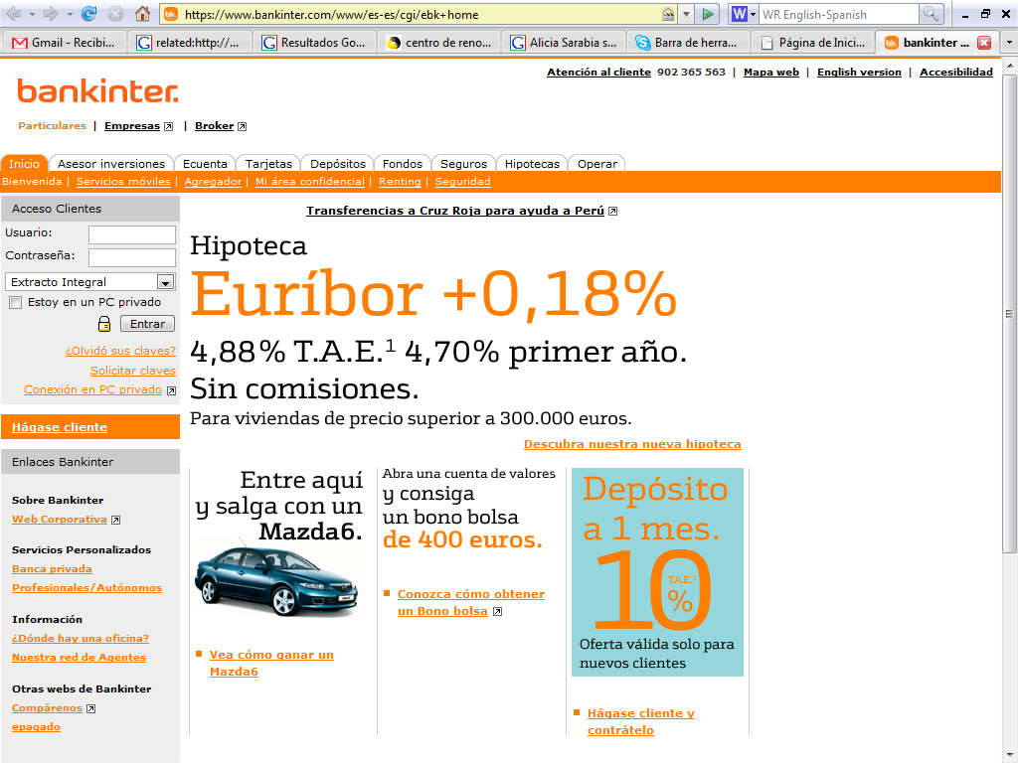
Image 1: The eBankinter website features the highest percentage increase: 51 points
- The official website of the City of Pamplona also showed a spectacular increase of nearly 43 percentage points after a complete overhaul of its website based on new templates that include the aspects on accessibility. The increase could not be any higher, since, following their overhaul, they have reached 100% success on the technical analysis performed on this website.
- Another website boasting improvement in the accessibility criteria analyzed was that of the Catalonian Regional Government, with an improvement of more than 34 percentage points. From 37.5%, it has climbed to nearly 72% success on the evaluation.
- Somewhat lower increases in the level of successful compliance with the criteria for accessibility are found in the list of websites nevertheless showing notable improvements: savings and loan bank Caja Madrid rose 18 percentage points from 25% to more than 43%; the official website of the City of Castellón de la Plana climbed nearly 17 percentage points from 52% to 69%; and the Madrid Mass Transit Consortium gained almost 14 percentage points, rising from 37.%% to more than 51%.
In the section on falling scores, Table 2 provides the following information:
- The City of Ceuta official website showed the greatest drop in percent score on the tests performed on it to verify the technical criteria of Web accessibility, losing almost 30 percentage points and falling from 56.62% to 26.83%.
- Three Regional Government official websites find themselves among the ones with worsened performance: the Basque Country lost almost 21 percentage points; Madrid felly by 19 percentage points; and Murcia dropped by almost 17 percentage points. Poor handling of conserving the characteristics of accessibility when running maintenance on these websites is likely to blame for their decline.
- Two websites belonging to the General Public Administration also showed a worse turnout on the analysis of their e-services: the process of filing a grievance with the Ombudsman, which lost 27 percentage points; and information on the Information Society at red.es, which dropped by nearly 18 percentage points. The same careless management of website maintenance as mentioned above would seem to apply here as well.
- Ending the group of websites showing worsened performance on the results of the technical analysis of Web accessibility is the University of Valencia website, which is seen to have lost more than 11 percentage points.
For the websites making up the “continuity” group, we underscore the following:
- The websites of Social Security, in their service for retrieving past tax records, and the savings and loan La Caixa have both kept up the favorable level they enjoyed in the earlier study. The differences between scores from the past and present studies (- 7.77 percentage points for Social Security and – 0.64 for La Caixa) are negligible; more importantly, their percent success scores on the tests are favorable (almost 86% for Social Security and nearly 61% for La Caixa).
- The remaining websites in this group (RENFE, the University of Navarra, the University of Seville, and AirEurope) maintained their poor scores verified on the prior study despite the recommendations given for improvement. Their scores range between 17% and 36% success in complying with the evaluated criteria for accessibility.

2.2. Classification by Percent Success
Table 3:
Percent success by website in the web accessibility analysis from June 2007
Website | % Success
City of Pamplona | 100.00
Social Security, tax records | 85.71
eBankinter | 81.08
Catalonia Regional Government | 71.79
City of Castellón de la Plana | 69.23
La Caixa Bank | 60.98
Madrid Mass Transit Consortium | 51.22
Red.es | 43.24
Caja Madrid Savings and Loan | 43.24
University of Navarra | 35.90
RENFE Spanish National Railway | 32.69
Murcia Regional Government | 30.95
University of Seville | 30.23
Ceuta Regional Government | 26.83
University of Valencia | 26.47
Ombudsman, grievance | 26.32
Madrid Regional Government | 25.00
Air Europa | 17.07
Basque Country Regional Government | 16.67
AVERAGE: | 45.18
Table 3 features the percent success scores obtained on the analysis of the technical criteria for Web accessibility carried out on all 19 websites in the sample, and ordered from highest to lowest.
The most noteworthy figure in Table 3 is the first appearance in our Observatory’s history of a website that successfully passed all the accessibility criteria evaluated on the sample of pages selected for this study. The City of Pamplona official website is the first we have been able to verify at 100% success. This clearly shows proves that it is indeed possible to reach that percentage of success without harming its appearance or usability.
This perfect score of success is based on a complete revision of the templates designed for this website. Furthermore, no use was made of problematic elements such as frames, tables for layout purposes, and semantic use of color to convey information. The sample for this website consisted of 4 pages, since we found no page using data tables, which had all been replaced by different types of lists.

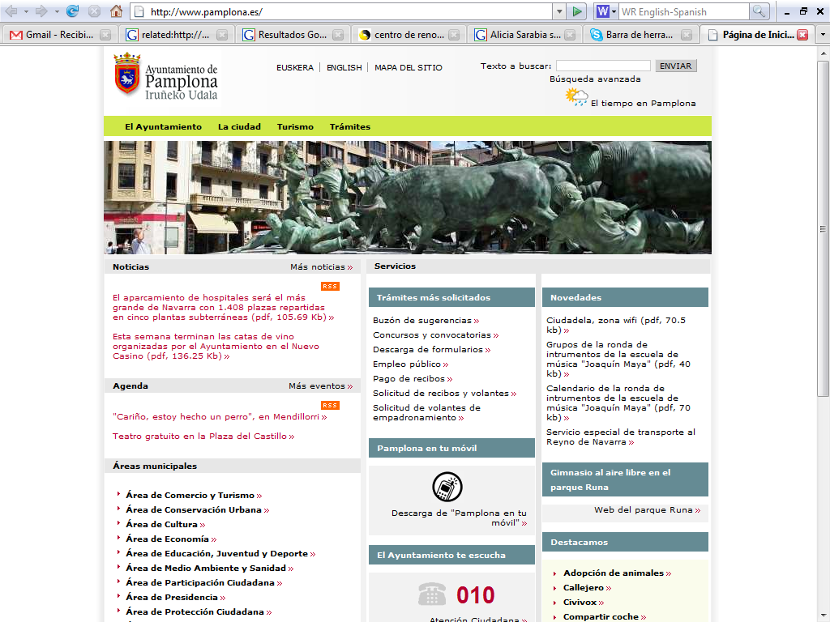
Image 2: The official website of the City of Pamplona is the first to score 100% success in applying the technical criteria of Web accessibility analyzed
Other website with noteworthy success scores are:
- The Spanish Social Security website’s service of accessing past tax records still makes a very good showing with a success rate of 85.71% despite a slight downturn from the previous study
- The eBankinter website soared 51 percentage points after careful planning of a thoughtful revision to reach a very good success rate of 81.08%
- The official website of the Region of Catalonia is the only Regional Government website analyzed that showed improvement, reaching a good success rate of 71.79%
- Three other websites (the official site of the City of Castellón de la Plana, at 69.23%, the bank La Caixa, at 60.98%, and the Madrid Mass Transit Consortium, at 51.22%) rank above the 50% success mark. Worthy as these scores are, it is equally worth noting that none of them qualify as “passing” grades in accessibility. Rather, these websites should be energized to reach higher rates of success in applying the criteria for accessibility
- There are twelve websites that fail to reach the 50% success rate, three of which (the official site of the Region of Madrid, Air Europe, and the official website of the Basque Country) failed to pass the 25% mark

2.3 Performance by Sector
As explained in the introduction to this report, the present study crosses sector lines. To do so, the sample consisted of the top performing websites in terms of Web accessibility from prior studies. We are therefore also interested in knowing how each sector performed on this comparative study.
Table 4 shows the average scores of the sample for each sector, from the percent success on the verification tests of the technical criteria for Web accessibility used in the present study (carried out in June 2007) as well as those from previous studies. Beside these figures is the difference between the two averages, which then indicates the improvement or worsening of each sector.

Table 4
Average percent success by sector, on both the analysis carried out in June 2007 and the previous study, and the difference between the two percentages
Sector | Average % Success: June 2007 | Average % Success: Previous | Difference in Averages
General Public Administration e-Services | 51.76 | 69.41 | - 17.65
Regional Governments | 36.10 | 41.77 | - 5.66
Universities | 30.87 | 35.17 | - 4.30
Official City Websites | 65.35 | 55.34 | 10.01
Travel and Transportation | 33.66 | 29.54 | 4.12
Banking | 61.77 | 38.85 | 22.92
From the data provided in Table 4 we note the following points:
- The sector showing the greatest improvement is Banking (nearly 23 percentage points), particularly due to the rise of eBankinter (which increased by 51 percentage points) and Caja Madrid (by 18 percentage points), not to mention the stability shown by La Caixa, which had already exhibited a good percentage of success on the previous study.
- The sector showing the best average success rate is that of Official City websites (65.35%), due to the high percentages found, especially on the City of Pamplona site (100%) and the City of Castellón de la Plana site (69.23%), and despite the poor showing of the Autonomous City of Ceuta site, which was the website that fell the most (by almost 30 percentage points).
- Second place for each section above (best improvement and best average score are the same sectors reversed: the second greatest improvement being Official City websites (with an improvement of 10 percentage points between the two average scores) and the second best average success rate is for the Banking sector (at 61.77%).
- The sector that declined the most is that of the General Public Administration in terms of its online e-services, which lost nearly 18 percentage points. This is due to the fact that all three websites sampled showed losses, particularly in the filing of grievances at the Ombudsman’s office, which plunged by more than 27 percentage points. Despite that decline, they still maintain an average above 50%, since they started off with top scores from the previous studies.
- The sector that shows the worst average score is that of Universities, whose websites did not quite reach 31% success in complying with the criteria for accessibility used. Its average fell by more than 4 percentage points from the average obtained in previous study, especially due to the more than 11 points lost by the University of Valencia. This has led to ranking the Travel and Transportation sector (which, at 33.66% in June 2007, improved by more than 4 percentage points) above the Universities.
- The sector of Regional Governments earned the worst average compliance rate (36.10%) of all the Public Administration sectors analyzed by this Observatory to date, showing a loss of nearly 6 percentage points from the first study to the last.

2.4 Performance by Verification Criteria
This section examines how the websites performed in terms of the 12 verification criteria used in the methodology of carrying out the technical analysis in this study.
Table 5
Percent success by criterion in the analysis carried out in June 2007
Criterion | % Success
Alignment tables for layout | 84.21
Format of data tables | 57.14
Alternative text in images | 53.26
Use of scripts | 51.76
Use of headers | 48.91
Use of forms | 46.97
Use of links | 46.24
Color contrast in images | 45.57
Use of Cascading Style Sheets | 35.48
Code validation | 21.51
Use of frames | 8.33
Semantic use of color | not applicable
Table 5 presents the percent success rates achieved for each criterion used in the technical analysis of Web accessibility in the present study on 19 websites and 93 web pages comprising the sample. The follow observations are drawn from the data displayed in the table:
- None of the pages analyzed made semantic use of color, which is not, in and of itself, a good sign, since for people with mental, cultural, or attention deficit, its use is helpful. The failure to use color to convey information may not be an obstacle, but it does imply missing out on an otherwise helpful tool (when used correctly).
- Of the 93 pages analyzed, there were 38 that used tables for content layout purposes. It should be recalled that the Worldwide Web Consortium (W3C) advises against its use, in favor of a layout by means of style sheets. Despite the data, this criterion scored the highest (84.21%) in the analysis of content alignment.
- Very few—only 14—data tables were found in the sample. More than half (8) were evaluated as having been made with an accessible design. This situates this criterion in second place in terms of successful compliance, at 57.14%. This figure should be taken cautiously owing to its scarcity in the sample compared to other criteria analyzed. It should be recalled, for example, that for people who use voice-controlled web browsers, it is vital that the contents of a data table be correctly labeled. To make a data table accessible, a summary of the content should be included with the attribute “summary” in the element “table”, and the header cells in rows or columns must be correctly labeled with the element “th”. Table with more than one logical level must use the elements “thead”, “tfoot”, and “tbody” to group the rows, and the elements “col” and “colgroup” to group the columns. The attributes “axis”, “scope”, and “headers” serve to describe more complex relationships. The element “caption” can be used to place the title of the data table being designed, to give information about their purpose.
- Text alternative to images, utilized so that screen readers and text-only web browsers can display their content and function, was correctly applied on 53.26% of the pages containing images. A web image should be accompanied by its text-based alternative by adding the attribute “alt” in the element “img”. This alternative provides information on the content and function of the image so that it can be rendered correctly by any user who cannot or does not wish to see or download the image.
- The accessibility criterion of scripts was respected on 51.76% of the pages that used them. This figure is considered very positive, since the criterion of correct use of scripts is often the worst-performing indicator in other studies. Scripts and programming objects are used to control certain aspects of Web browsing and performance. Their use should follow certain rules so that the user does not find himself unable to interact with a website because of not having the corresponding control activated on his side. An alternative should be provided for people who do not have these devices activated, and event managers should not be created that depend on specific input devices (e.g., a mouse or keyboard). To prevent the user of the page from being left without any information because of not being able to use the driver of the programmed object, the element “noscripts” should be used to provide an alternative.
- Headings were used correctly on 48.91% of the pages that used them. To make documents easier to understand and browse, header elements (<h1>, <h2>, <h3>…) should be used. The text format for this element should be controlled from the style sheet, and the use of formatted text to define block limits on the web page should be avoided. Furthermore, the order of levels of depth should be respected in the headers. Jumping from a first-level header to a third-level header should likewise not be done. If another format must be applied to a second-level header for display purposes, it is best done from the style sheet.
- Forms were used correctly on 46.97% of the pages making use of them. A correct design of Web forms should match fields to their controls by means of the element “label”. Forms should not be made very lengthy: if necessary, the form should be divided into various steps on different pages. In addition, fields should always be grouped together by theme or concept my means of the element “fieldset”. In text boxes and edit boxes, it is recommended to put in some default text, since there are helping devices that cannot focus on empty controls.
- The correct and comprehensible use of links, many of which are placed inside images, showed 46.24% compliance on the pages analyzed. Most of the mistakes in this section centered on poorly applying (or not at all) a text alternative to images that act as links to other pages or sites. Another common error is that of not respecting the order of presentation of the links, skipping around the screen among consecutive links, which may confuse people who navigate among the links. As a general rule, to check that a link’s text is comprehensible, it should be enough to read it out of its context. Whenever more information is required, the attribute “title” must be used in the element “a” that marks the link. It is essential to use text alternatives to images used as links. To give more information on the destination of the link in an image, the attribute “title” must be used in the element “img”. It is recommended to group related links into lists by using the elements “ul” or “ol”.
- Color contrast in images conveying text-based information was applied correctly on 49.54% of the pages. Before publishing on the web, it should be checked that there is enough color contrast to be perceived by all possible users. Automatic tools such as Color Contrast Analyzer, from WAT-C, which are helpful in performing this check. Text colors should be stated in the style sheet so that they may be de-activated by any user who must use a personal style sheet to view greater contrast with the background color. The use of background images—wallpaper—on which text or other images are displayed should be applied with caution, checking that there is enough contrast for correct viewing.
- Of the web pages evaluated, 35.48% made correct use of the accessibility characteristics of cascading style sheets (CSS). Style sheets should always be used to lay out web pages. The units controlling text size must be relative in order to allow the user to set the font to personal preferences. The elements and attributes employed in page layout must not have been declared obsolete by formal grammars; automatic tools can be used to verify this. Before a web page is uploaded, it is also a good idea to check its content for accessibility and navigability without using the style sheet.
- Validation of HTML and CSS codes was correct on 21.51% of the pages analyzed. Correction by automatic verification would greatly improve this meager score. To avoid the problem, we recommend revising the coding (mainly in the templates used in designing the site) and verifying it by the tools recommended by W3C.
- Only 12 pages in the sample used frames for layout purposes, and of them, only 1 did so correctly, giving a success rate of 8.33% for this criterion. The use of frames is in clear retreat, but when it is used, its accessible form is not usually taken into account. Our recommendation is not to use any design technique based on frames, since there are currently other, more comfortable and accessible techniques that offer the same possibilities. But if frames are to be used, the attributes “name” and “title” along with the element “noframe” should not be forgotten when designing the website.
We were also interested in knowing whether the success rate for each verification criterion varied between the current study and the study run previously on each of the websites making up the sample.
Table 6
Percent success by criterion, on the analysis from June 2007 as well as the prior study, and the difference between both percentages
Criterion | % Success  June 2007 | % Prior Success | Difference
Code validation | 21.51 | 14.89 | 6.61
Use of frames | 8.33 | 56.25 | - 47.92
Use of forms | 46.97 | 29.03 | 17.94
Text alternative in images | 53.26 | 54.84 | - 1.58
Use of headers | 48.91 | 23.08 | 25.84
Use of Cascading Style Sheets | 35.48 | 28.72 | 6.76
Use of comprehensible links | 46.24 | 64.89 | - 18.66
Color contrast in images | 45.57 | 43.37 | 2.20
Semantic use of color | n/a | 100.00
Tables for layout purposes | 84.21 | 96.15 | - 11.94
Data table format | 57.14 | 33.33 | 23.81
Use of scripts | 51.76 | 46.67 | 5.10
AVERAGE | 40.94 | 41.62 | 0.68
Table 6 presents the results in terms of the success rate for each criterion verified in the technical analysis of Web accessibility, on the current study as well as on the previous one, and the difference in percentage points between the two rates.
Noteworthy in the data shown in Table 6 are the following observations:
- As a whole, the set of criteria shows no variation between the data from previous studies and those of the present study. However, there are notable differences in some of the criteria when taken individually. The use of color to convey information is left out of the valuation, since no use of this technique was found on any pages in the current study, while previous studies found only one example (used correctly), thus making the data irrelevant.
- The best-improving criteria were those regarding the correct use of headers (nearly 26 percentage points gained) and of data table format (nearly 24 percentage points gained).
- Another criterion that showed notable improvement is the correct use of accessibility characteristics in designing forms (increasing by almost 18 percentage points).
- On the downside, the criterion showing the worst decline is that of using frames for layout purposes (dropping almost 48 percentage points).
- The design of links (which fell by almost 19 percentage points) as well as aligning content of tables used for layout purposes (which lost nearly 12 percentage points) are the two other criteria whose performance worsened over the time between the two studies. It should be pointed out that tables for layout purposes fell from 78 pages found on previous studies to 38 pages making use of this technique in the current study. This downward trend is favorable, since it helps the behavior of some support technologies (such as some screen readers that have trouble presenting contents inserted into tables).
- The rest of the criteria showed no noteworthy variation, since they fall below a margin of +/- 10%.

3 Conclusions
From the data presented herein, we draw the following conclusions:
- Taken as a whole, the results show a similar status in the accessibility of the websites analyzed. The variation between the current study and prior studies is only + 0.34%.
- This continuity in the overall results does not match a continuity in the score for each website. Rather it shows the existence of three differentiated groups (6 websites improved, 6 stayed the same, and 7 changed for the worse) whose scores cancelled each other out.
- The website showing the greatest improvement in terms of an increase in percentage points from the last study to this one was the eBankinter website, which improved its score by more than 51%. The improvement witnessed on this website was based on correcting many of the errors that had been detected in the previous study while preserving the general design of the site.
- The website featuring the greatest success on the technical analysis was the City of Pamplona, which scored a praiseworthy 100%. This was the first time this Observatory has found a website displaying such a perfect success rate, and reaffirms our belief that it is possible to achieve such a positive score. This should set an example for other websites. The success of eBankinter was based on a complete overhaul of the templates used on their website.
- The Spanish Social Security website and the La Caixa website started off with good results and knew how to keep them, with no significant variation between the two studies.
- The websites whose performance actually worsened the most were those of the City of Ceuta (which fell by almost 30 percentage points) and the Ombudsman (which fell by more than 27 percentage points). Along with three Regional Governments (the Basque Country, Madrid, and Murcia), the Red.es website, and the University of Valencia, they are the ones exhibiting a significant decline. None of them had modified its design, which leads one to believe that the worsening is due to problems in maintaining its content. We have verified that maintenance on these sites is done by personnel lacking any specific training or advanced knowledge in Web design and the characteristics for accessibility.
- The sector showing the greatest improvement on this study is that of Banking (with an average increase of nearly 23 percentage points). Two of the websites (eBankinter and Caja Madrid) improved notably, while the third (La Caixa) has conserved its good score.
- The sector featuring the highest average score of all the websites making up this study is that of City Halls (63.35%). This figure, like the previous one, should be taken with due caution because of the small sample size of the sector represented.
- In regard to the success rate per criterion, one would highlight the performance of table alignment for layout purposes. This technique is used much less often than before (present on 78 pages previously and now on only 38), and more than 84% of the pages using them did so correctly and accessibly.
- On the down side, the criteria that achieved the lowest success rates were: the correct use of frames, at little more than 8% among the few pages using them (only 11 pages in the sample), and the validation of HTML and CSS codes, at 21.51%, which would seem rather low considering it is a criterion that can be verified automatically.

4 Recommendation
It appears, at least for some of the people responsible for some of the websites, that Web accessibility is beginning to take root.
Happily, we see success rates of compliance with the criteria for evaluating Web accessibility reaching new highs, and we have even found the first example of one at 100% with the City of Pamplona, thanks to their complete revision of their templates and the reorganization of their content.
We also happily observe that there are websites that have revised the design they were using and have managed to correct them and adapt them to the criteria of Web accessibility. Examples such as the websites from eBankinter and the Regional Government of Catalonia may act as good references for other websites who rise to the task of improving their accessibility.
What saddens us is that the efforts of some are counteracted by the carelessness of others. The seven websites showing noticeably worsening performance are all from public initiative. From what we have been able to see, poor maintenance is behind their declining performance.
Our recommendation is that any effort made in the design phase to achieve compliance with the criteria of accessibility must be accompanied by suitable professional training for the people in charge of keeping the sites up and running. We can see that some websites have undertaken the effort of complying with the characteristics for accessibility only to find, a few months later, that all their work amounted to nothing because of slipshod maintenance that left such accessibility characteristics on the wayside.

The results of the study on accessibility of online newspapers were still forthcoming at the time this report was prepared, and thus are not included herein.
This tool is free and available at: http://www.wat-c.org/tools/CCA/1.1/index.html

