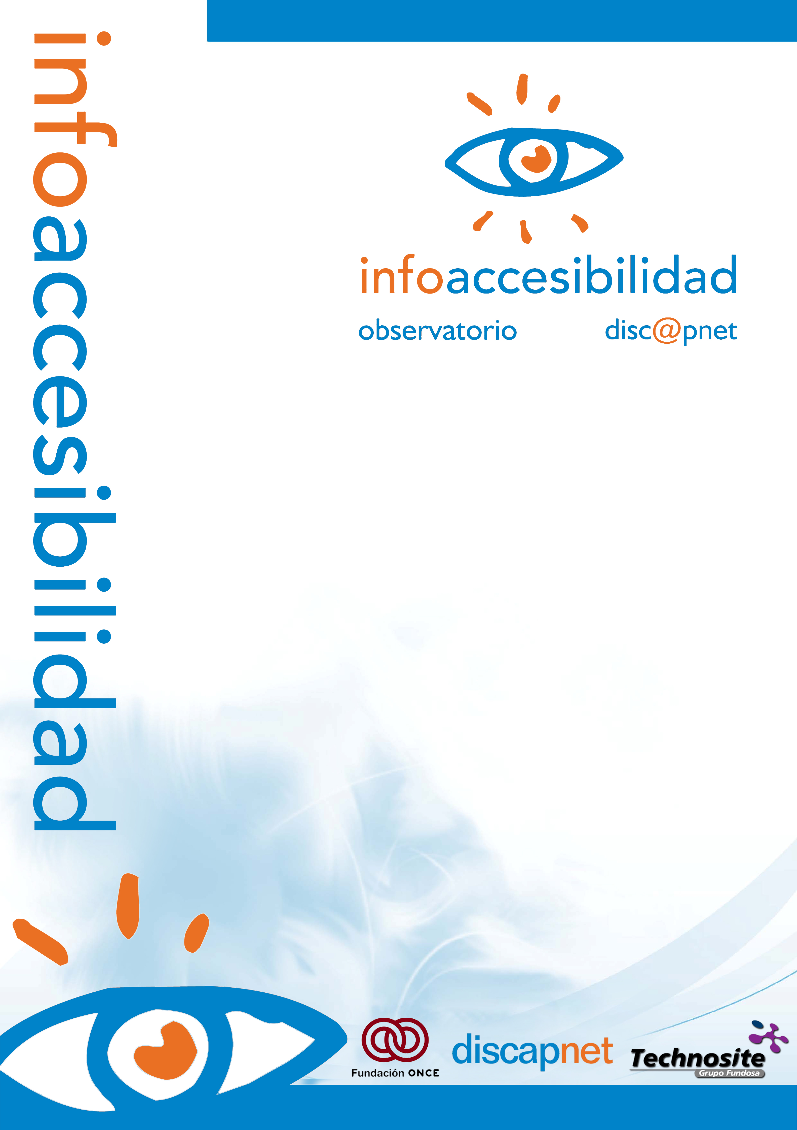
Propuesta Especial para:

Accessibility of
University Websites in Spain
June 2010

Summary
- Introduction
The Discapnet InfoAccessibility Observatory has been carrying out, since 2004, sector-specific surveys of website accessibility in Spain. With these surveys, the Observatory serves to “raise awareness and highlight not only the degree of compliance with current guidelines, but also good practices and the main barriers on the web.”
In 2004 and 2006 the Observatory published surveys of the accessibility of university websites, thus fulfilling one of its objectives: monitoring changes in accessibility over time.
Firstly, in August 2004, the Discapnet InfoAccessibility Observatory carried out a survey of the accessibility of university web sites in Spain. More than a year and a half after that survey was carried out, and after the passing of the statutory deadline, laid down in the Fifth Additional Provision of Law on Information Society and Electronic Commerce Services for adaptation of publicly provided Web content to "generally recognized" accessibility criteria, the Observatory working group undertook a new review of the websites analysed in the previous survey. The aim was to check for any improvements made during that time, to make the contents of the universities' websites more accessible to people with functional impairments.
As a result of this survey we published the report Accessibility of University Websites (Accesibilidad en los Portales Web Universitarios), in February 2006, which showed that there had been no change in the accessibility of university websites in Spain.
In 2010 we carried out another analysis of compliance with accessibility criteria, specifically a set of twelve checkpoints we consider indicative of overall compliance with the levels A and AA of W3C/WAI’s Web Content Accessibility Guidelines (WCAG 1.0). This analysis shows some improvement in the accessibility of university web sites, probably due to redesign which now incorporates accessibility criteria in the implementation and development of templates and content.
Web pages included in the survey sample, as in 2006, are from the following university sites:
- Seville University: http://www.us.es/
- Madrid Complutense University: http://www.ucm.es/
- National Distance Education University (UNED) http://www.uned.es
- University of Granada: http://www.ugr.es
- University of Barcelona: http://www.ub.es/
- University of the Basque Country http://www.ehu.es/
- University of Valencia: http://www.uv.es/
- University of Las Palmas de Gran Canaria: http://www.ulpgc.es/
- University of Alcalá de Henares: http://www.uah.es/
- Universitat Oberta de Catalunya: http://www.uoc.edu
- University of Deusto: http://www.deusto.es
- Valladolid University: http://www.uva.es/
- University of Navarra: http://www.unav.es/
- University of Santiago de Compostela: http://www.usc.es
- Ministry of Education, Culture and Sport, University inquiries website: http://www.educacion.es/educacion/universidades.html
- Conference of Spanish University Rectors: http://www.crue.org/
To evaluate the degree of accessibility of university websites we applied a methodology developed by Technosite. This methodology is based on W3C/WAI document Evaluating Web Sites for Accessibility, which includes evaluation of compliance with twelve aspects or accessibility criteria to cover most of the W3C/WAI Web Content Accessibility Guidelines 1.0 (WCAG 1.0), at levels A and AA.
The Technosite experts who designed the survey believe that these criteria provide an overall view that reliably reflects the accessibility of a website or a web-based online service. They mostly include priority 1 aspects, and in some cases, priority 2.
It is to be both expected and desired that by the time this report is published, some of the websites analysed have been upgraded and have improved their accessibility level. Whatever has happened since would not diminish the validity of the results presented in this report which relate to the date the data was collected (May 2010).
- Summary of Results
This survey examines the main accessibility barriers identified in an analysis of a sample of Spanish university websites in relation to the currently applicable W3C/WAI Web Content Accessibility Guidelines 1.0 (WCAG 1.0). The technical accessibility analysis takes into account a set of accessibility criteria based on the above guidelines. The result of this analysis should be taken as a reference for understanding compliance with current accessibility legislation.
The results indicate that, compared with the 2004 and 2006 surveys, average compliance with the criteria has improved, though few sites in the sample score over 50%, and only two obtain significantly positive results: the Ministry of Education's Universities website and that of the Madrid Complutense University.
The success rate of the websites surveyed is 39.39%, which is the best so far in any of the Observatory's surveys. Of all the websites evaluated, the one that obtained the best result was the Ministry of Education's Universities information site, with 81.43% compliance with the criteria. Figure 1 shows the site's start page.
Figure 1
Start page of the Ministry of Education's Universities site
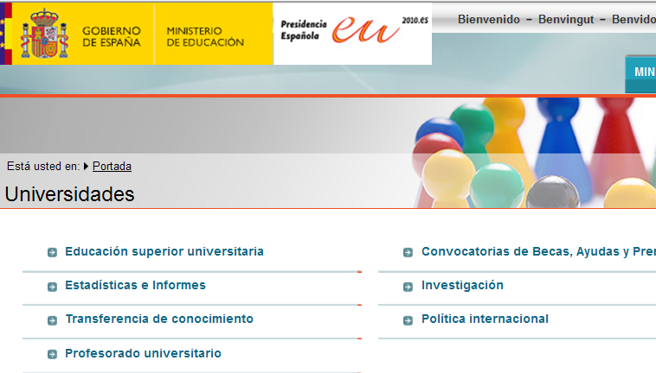
Below are the results of the technical evaluation of the accessibility of each web site. The tables in which the results are presented are ordered by degree of compliance with the accessibility criteria set out in current legislation:

1. Websites with a level of compliance with accessibility criteria between 100% and 70%: compliance with current legislation.
They are characterized by having achieved a high level of success in technical analysis of accessibility, compliance with almost all of the criteria based on WCAG 1.0.
Table 1
Sites with greater accessibility
Website | % pass (accessibility)
Ministry of Education, Universities information page | 81.43%
Madrid Complutense University | 72.38%

2. Websites with a level of compliance with the evaluated accessibility criteria between 70% and 50%: moderate compliance with current legislation.
The level of compliance is not as notable as with the websites listed in the table above, but can be considered moderate.
Table 2
Moderately accessible websites
Website | % pass (accessibility)
University of the Basque Country | 54.91%
University of Barcelona | 54.29%

3. Websites with a level of compliance with the evaluated accessibility criteria below 50%: non-compliant with current legislation.
These sites are characterized by a low accessibility level, with many difficulties and barriers to accessing content for people with disabilities.
Table 3
Inaccessible Web sites
Website | % pass (accessibility)
University of Las Palmas de Gran Canaria | 45.71%
University of Santiago de Compostela | 44.52%
Conference of Spanish University Rectors | 36.35%
University of Alcalá de Henares | 35.08%
University of Valladolid | 32.5%
University of Granada | 31.90%
University of Deusto | 26.79%
The University of Seville | 26.22%
University of Navarra | 25.833%
University of Valencia | 24.40%
Universitat Oberta de Catalunya | 24.12%
National Distance Education University (UNED) | 13.84%
The following table summarizes the percentage results obtained in the technical evaluation of the sample of sixteen university websites in terms of criteria met, not met, not applicable and success rate, from highest to lowest.
The table shows that four exceeded the required minimum of 50%, with particularly high compliance with accessibility criteria by the Ministry of Education's Universities website and Madrid Complutense University.
Table 4
Criteria met, not met, or not applicable, and percentage success for each site (2010)
Website | Good | Bad | N/A | % pass
Ministry of Education, Universities information page | 26 | 6 | 28 | 81.43%
Madrid Complutense University | 24 | 9 | 27 | 72.38%
University of the Basque Country | 21 | 15 | 24 | 54.91%
University of Barcelona | 19 | 16 | 25 | 54.29%
University of Las Palmas de Gran Canaria | 16 | 19 | 25 | 45.71%
University of Santiago de Compostela | 16 | 21 | 23 | 44.52%
Conference of Spanish University Rectors | 12 | 22 | 26 | 36.35%
University of Alcalá de Henares | 13 | 25 | 22 | 35.08%
University of Valladolid | 13 | 27 | 20 | 32.50%
University of Granada | 11 | 23 | 26 | 31.90%
University of Deusto | 10 | 28 | 22 | 26.79%
The University of Seville | 12 | 34 | 14 | 26.22%
University of Navarra | 11 | 30 | 19 | 25.83%
University of Valencia | 8 | 26 | 26 | 24.40%
Universitat Oberta de Catalunya | 7 | 27 | 26 | 24.12%
National University of Distance Education | 5 | 34 | 21 | 13.84%
AVERAGE | 224 | 362 | 374 | 39.39%

Graph 1
Percentage of compliance with web accessibility criteria by
university websites in Spain (May 2010)
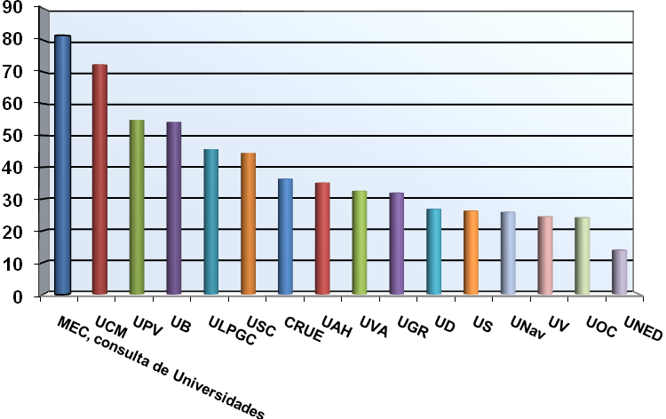
Table 5 and Graph 2 show the results obtained for each of the criteria considered. The criterion for which compliance was highest was that for layout tables; the success rate indicates cases in which the content is laid out with tables and these linearize correctly, which is necessary for screen reader users.
In general, since the results obtained in the evaluation of almost all websites are better, compliance with the criteria has also improved since the 2006 survey.
Table 5
Number of times applicable, met, not met, and percentage success for criteria evaluated.
Criterion | Applies | Good | Bad | % pass
LAYOUT TABLES | 44 | 39 | 5 | 88.6%
CONTRAST | 40 | 21 | 19 | 52.5%
CSS | 80 | 32 | 48 | 40%
LINKS | 79 | 31 | 48 | 39.2%
IMAGES | 80 | 31 | 49 | 38.7%
FORMS | 57 | 22 | 35 | 38.6%
HEADINGS | 80 | 28 | 52 | 35%
DATA TABLES | 15 | 5 | 10 | 33.3%
SCRIPTS | 33 | 10 | 23 | 30.3%
MARKUP VALIDATION | 80 | 6 | 74 | 7.5%
FRAMES | 2 | 0 | 2 | 0%
SEMANTIC USE OF COLOR | 0 | 0 | 0 | 0%
Graph 2
Percentage pass rate for technical evaluation criteria.

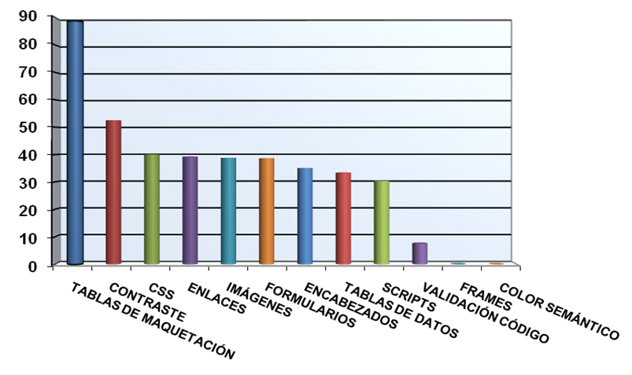

- Discapnet InfoAccessibility Observatory
In 2004 Discapnet launched its InfoAccessibility Observatory in order to generate and publish information on the levels of web accessibility, both by analysing specific sectors as well as comparing across sectors and monitoring change in accessibility over time.
The purpose of the Discapnet InfoAccessibility Observatory reports is to show the degree of compliance with current guidelines on web content accessibility, and highlight good practice and the major barriers and impediments on the web, including in its assessments the user perspective. A better understanding of the strengths and weaknesses recognized by experts and users in the websites of different sectors and give website managers, designers and developers a better understanding of accessible web design, tools and services and provide suggestions for improvement, as its importance is growing every day.
The Observatory employs an innovative methodology developed by Technosite. In line with W3C/WAI recommendations, this methodology combines technical analysis of accessibility with an assessment of usability and accessibility based on user experience.

The survey is available on the Web: http://www.discapnet.es/Discapnet/Castellano/Observatorio_infoaccesibilidad/observatorio04.htm
The University of Santiago de Compostela website was included in the sample at its own request.
http://www.w3.org/WAI/eval/
For further information, see Appendix II.
The complete results table is in Appendix IV.
W3C/WAI: Web Accessibility Initiative, the World Web Consortium (World Wide Web Consortium.)For more information, see http://www.w3.org/WAI

